RAJALAKSHMI ENGINEERING COLLEGE

**RAJALAKSHMI NAGAR, THANDALAM – 602 105**



|  |
| --- |
| **CS23A34**  **USER INTERFACE AND DESIGN LAB** |
| **Laboratory Observation NoteBook** |

**Name :** SUBASH KRISHNAN A

**Year/Branch/Section :** II/CSE/D **Register No. :** 230701345

**Semester :** IV **Academic Year:** 2024-25

**Ex. No. : 7 Date : 05.04.2025**

**Register No. : 230701345 Name : SUBASH KRISHNAN A**

**Develop low-fidelity paper prototypes for a banking app and convert them into digital wireframes using Pencil Project**

# AIM:

The aim is to develop low-fidelity paper prototypes for a banking app and convert them into digital wireframes with Pencil Project.

# PROCEDURE:

Tool Link: https://pencil.evolus.vn/

## Step 1: Create Low-Fidelity Paper Prototypes

1. Define the Purpose and Features: ○ Identify the core features of the banking app (e.g., login, account balance,transfers, bill payments).
2. Sketch Basic Layouts:
   * Use plain paper and pencils to sketch basic screens.
   * Focus on primary elements like buttons, menus, and forms.
3. Iterate and Refine:
   * Get feedback from users or stakeholders. ○ Iterate on your sketches to improve clarity and

functionality.

## Step 2: Convert Paper Prototypes to Digital Wireframes Using Pencil Project

1. Install Pencil Project: ○ Download and install Pencil Project from the official website.
2. Create a New Document:
   * Open Pencil Project and create a new document.
3. Add Screens: ○ Click on the "Add Page" button to create different screens (e.g., Login,Dashboard, Transfer).
4. Use Stencils and Shapes:
   * Use the built-in stencils and shapes to create UI elements.
     + Drag and drop elements like buttons, text fields, and icons onto your canvas.
5. Organize and Align: ○ Arrange and align the elements to match your paper prototype.
   * Ensure that the design is user-friendly and intuitive.
6. Link Screens:
   * Use connectors to link different screens together. ○ Create navigation flows to show how users will interact with the app.
7. Add Annotations:
   * Include annotations to explain the functionality of different elements.
8. Export Your Wireframes: ○ Once satisfied with your digital wireframes, export them in your preferred format (e.g., PNG, PDF).

# OUTPUT:

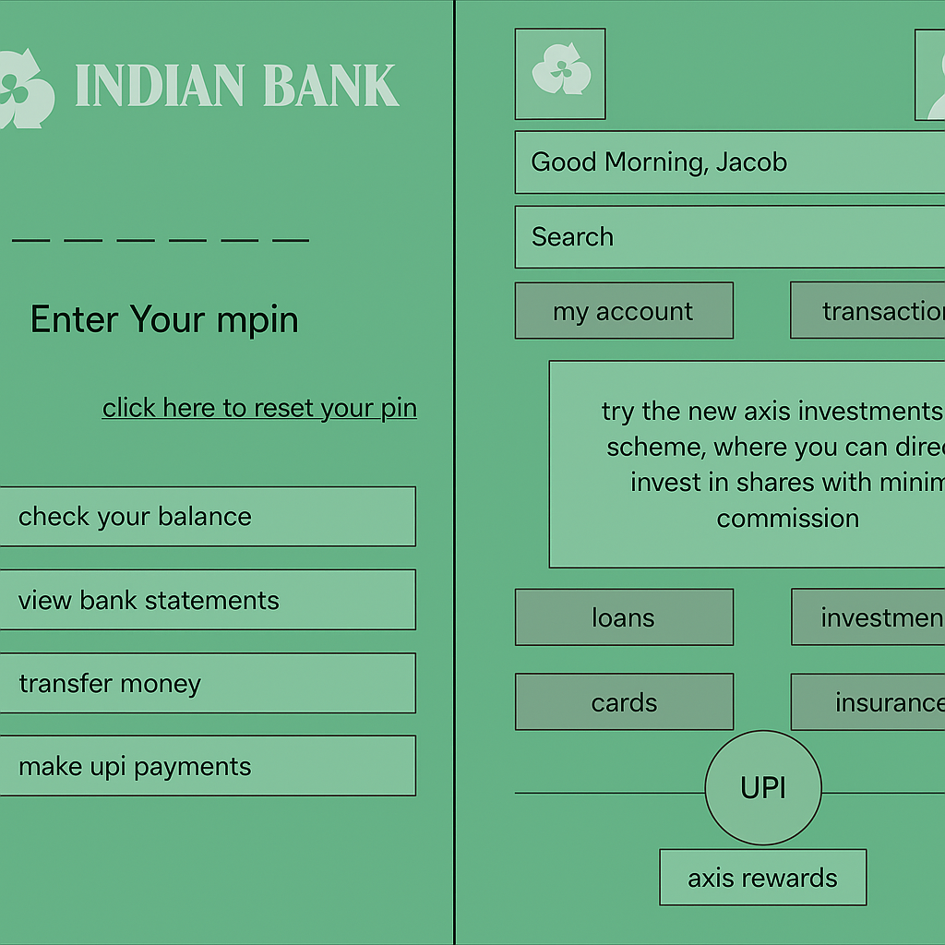

**RESULT:**

Hence low-fidelity paper prototypes for a banking app and convert them into digital wireframes with Pencil Project have been successfully executed.